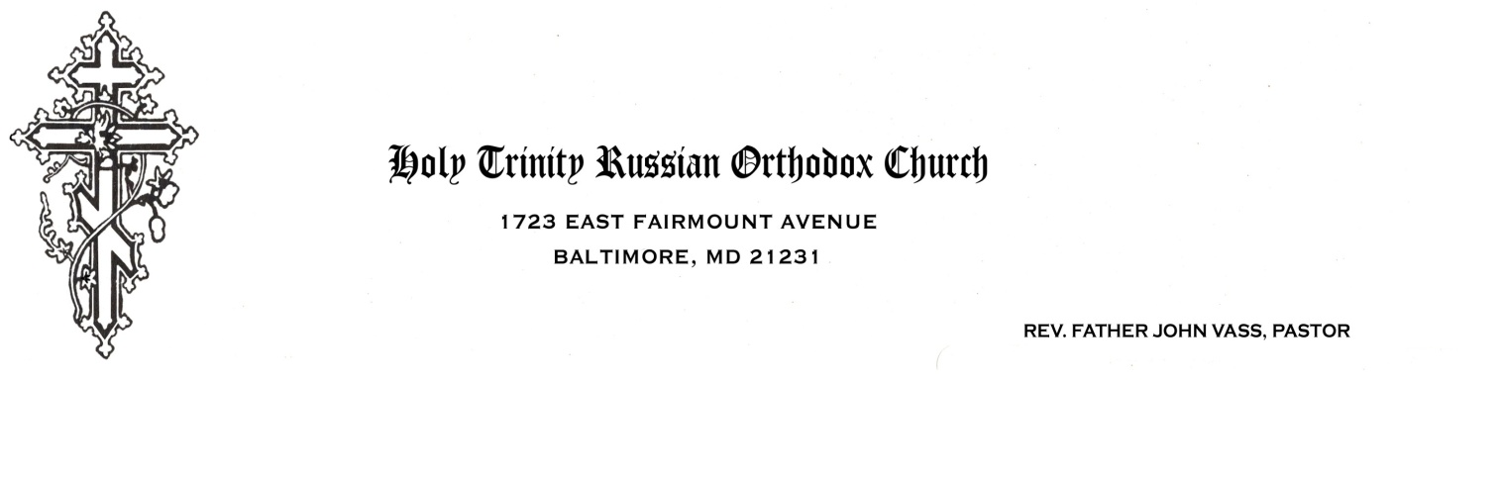

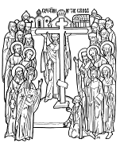

**Holy Cross**

Orthodox Church

105 N. Camp Meade Rd.

Linthicum, MD 21090

January 6, 2018

Dear friends in Christ,

The time for our eighteenth annual Church School camping trip is approaching. This may seem a bit early for our annual invitation, but I know how busy schedules get in May and it doesn’t hurt to get on the calendar early. We are scheduled Friday, May 18, to Sunday, May 20, 2018 – the week after Mother’s Day. I have enclosed a sample permission slip for you to complete and hand out to any interested children, ages 6-12. There is also a packing list and general outline of activities. Our theme this year will be “Prophecies of the Messiah” with a review of the Old Testament and the preparation of the Jewish people for the coming of the Lord Jesus.

I would like to have final numbers by no later than May 1; you may want to ask your people to turn the slips and money in to you a bit earlier in order to allow for “latecomers”. You, the Church School director, can pay me in a single check, made out to Holy Trinity Church, at the time of the event, but I will need to receive the entire fee for the number of people you told me would be attending, without any cancellation of fee for last-minute cancellations, since purchases will already have been made. I would suggest you collect the money with the registrations; of course, if someone cannot come and someone else wants to, a trade is quite in order. Parents are welcome and will be put to work helping to run the camp, along with our staff of teens. We are going this year to Camp Running Bear in Monkton, the same camp as last year.

This should be great fun! Hope to see you and your Church School at Camp Running Bear!

Sincerely,

Dr. Pat Disharoon

Camping Trip Director

PDisharoon@aol.com

410-233-5337

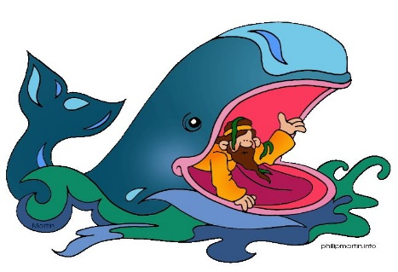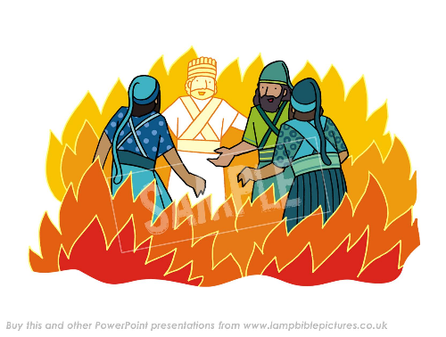**Pan-Orthodox Church School**

**Ages 6-12**

Camping Trip

**Friday thru Sunday, May 18-20, 2018**

**Camp Running Bear, Monkton, MD**

All Students ages 6-12, Teachers and Parents of Orthodox Church Sunday Schools in the Greater Baltimore region are invited to attend. We’ll be learning all about the Old Testament Prophecies of the Messiah.

Prophecies of the Messiah

Including all kinds of fun camping activities:

Camp Shirts and Hats from the Old Testament

All meals Saturday, brunch on Sunday + ice cream social

Crafts – Flannel boards and all sorts of candles!

Skits and Songs about the Old Testament. Jewish dancing.

Ropes Course and our very own Treasure Hunt

Campfire – sing-a-long around the fire and s’mores!

**What to bring??? Packing list attached**

**Permission slip attached**

**Cost: $25 for first camper/family, and $15 for additional children and adults**

**Church School Directors and Families, please RSVP by May 1:**

Pat Disharoon, Camping Trip Coordinator

513 Stamford Road, Baltimore, MD 21229

Questions? Contact Dr. Pat at 410-233-5337 or [PDisharoon@aol.com](mailto:PDisharoon@aol.com)

-------------------------------------------------------------------------------------------

Yes, we’re coming on the camping trip, May 18-20, 2018

Parish ___________________________________________

# of students _____ Permission slips enclosed.

# of parents _____

Total money enclosed: _____ Checks payable to Holy Trinity Russian Orthodox Church

Any special needs?

PARENT/GUARDIAN PERMISSION FORM

WHO………………………………..Church School, ages 6-12.

**WHAT………………………………Camping trip.**

**WHERE…………………………….Camp Running Bear, Monkton, Maryland: Take 83**

**North to Mt. Carmel Road,Right on Mt. Carmel,**

**right on York, immediate left on Monkton Rd.,**

**left fork onto Big Falls. Camp entrance on**

**right, take left fork for Camp Running Bear**

**WHEN………………………………Friday, May 18- Sunday, May 20, 2018**

**START TIME………Friday, 7 PM FINISH TIME……Sunday, 12 Noon**

**COST……………………………….$25 for first camper, $15 for subsequent children**

**and adults**

**WHAT TO BRING………………..See enclosed list**

**ADULT IN CHARGE**/**FIRST AIDER** – Pat Disharoon, M.D.

# PLEASE KEEP TOP HALF FOR YOUR RECORDS

**RETURN BOTTOM HALF OF FORM**

My child_______________________has my permission to participate in the field trip to Camp Running Bear.

________I am willing to drive for the event. My car holds ____ children, in seat belts, including my own child.

________I would like to attend with my child. Extra $15 enclosed to cover camp costs.

________I will not be at home during this activity. In case of emergency, please contact ______________________ at ____________________.

My child is allergic to _____________.

My child is on the following medications _____________________.

My child has the following chronic medical problems __________________.

______My child has had all of his/her required Maryland school immunizations.

I hereby give permission for the staff of the Church School camping trip to authorize any necessary emergency medical care for my child(ren).

___________________ _____________________________________

date parent signature

PACKING LIST FOR CAMPING TRIP

Bedroll or sleeping bag

Extra blanket

Pillow

Flashlight with extra batteries

Brush or comb

Toothbrush and toothpaste

Soap, washcloth, towel

2 changes of clothing – at least one outfit should be long pants

and one long-sleeved shirt even if it’s hot out

Extra socks and shoes

Rain gear – we’ll be outdoors regardless of weather

Pajamas

Unbreakable drinking cup

Lovey – special doll, stuffed animal, blanket, etc.

Coat or warm jacket

Insect repellant, Sunblock, any prescription medicines with directions

**Bible and prayer book, if child is old enough to read**

No, no, no extra snacks or food; if kept in cabins, these will attract unwanted

rodents and bugs. No radios or music players. No electric appliances or cell phones.

All gear should be placed in a single (That means one!) duffel bag or plastic garbage bag labeled with the child’s name. No child should bring more gear than he himself can carry in one load; make sure the load is well-packed so it won’t fall apart on your child as he carries it to his tent or cabin. Be sure to label each item.