Archbishop of New York and
Metropolitan of
All North America

Diocese of Oakland, Charleston, and the Mid-Atlantic

His Eminence The Most Reverend
Metropolitan JOSEPH

The Right Reverend
Bishop THOMAS
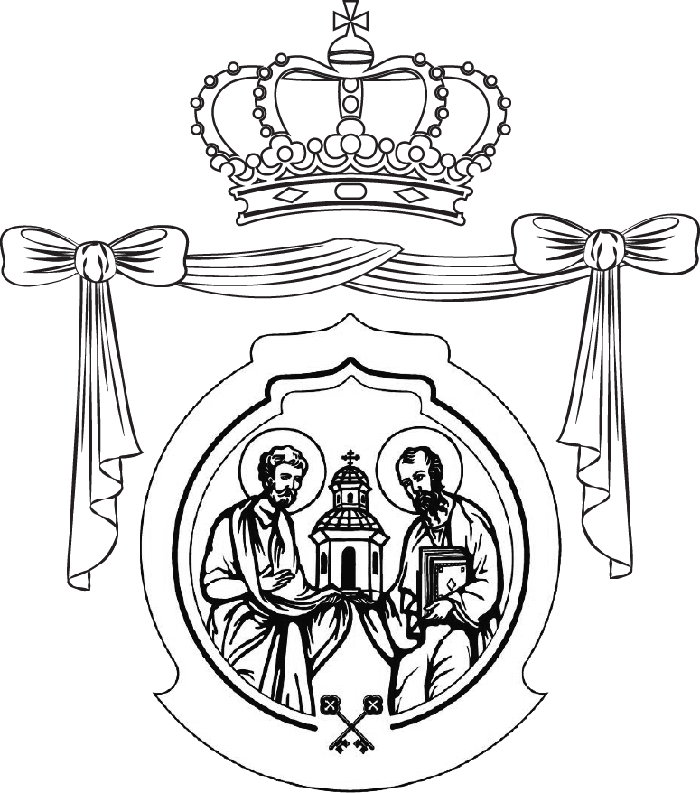

Antiochian Orthodox Christian Archdiocese
OF NORTH AMERICA

June 4, 2017
Pentecost

Beloved brother Hierarchs, Reverend Clergy, God-fearing Monastics,
and all my Brothers and Sisters in Jesus Christ our True God:

Nevertheless I tell you the truth; It is expedient for you that I go away: for if I go not away, the Comforter [that is, the Holy Spirit], will not come unto you; but if I depart, I will send him unto you. Howbeit when he, the Spirit of truth, is come, he will guide you into all truth (Jn. 16:7, 13).

On this feast of Pentecost, I greet you in the name of the thrice-holy Trinity, the Father, and the Son, and the Holy Spirit! Our Creator and our Savior now also becomes our Comforter! In the words of Saint Theodore the Studite, “O, the unutterable love for mankind! God Himself has become our Comforter. Thus, He Himself comforts those who are weighed down by misfortune, prevents them from becoming exhausted in spirit, as the Holy Apostle testifies, saying: Our flesh had no rest, but we were troubled on every side; without were fightings, within were fears. Nevertheless God, that comforteth those that are cast down, comforted us (2 Cor. 7:5–6). He comforts the heart frightened by demonic fear, raising it up to invincible courage through bold hope, as the Prophet David testifies: For Thou, O Lord, hast holpen me and comforted me (Ps. 85:17). He comforts, encouraging the troubled mind, as it has been given a feast with God and rest, as the Apostle testifies, saying: as though God did beseech you by us: we pray you in Christ's stead, be ye reconciled to God (2 Cor. 5:20); that is, have peace, with God.”

The love of God for His creation is boundless and knows no measure. Our response to His munificence should echo the sentiments of the Psalmist, “What shall I render unto the Lord, for all that He has rendered unto me?” (Ps. 115:4). The Comforter descends from on high to assist us in the spiritual struggle and remind us that we have purchased at a great price. Saint Theodore reminds us, as a result of this, “we shall not be afraid of the enemy and shall not be frightened by opposing powers, but shall courageously and steadfastly hasten to the struggle and feat, experiencing them day after day, not being deluded by the deceptions of the snake, and not growing weary from his ceaseless attacks.”

On this feast of Pentecost we are emboldened to cry out, “O Heavenly King, Comforter, Spirit of Truth, Who art everywhere present, and fillest all things, Treasury of good gifts, and giver of life, come and abide in us, and cleanse us of all impurity, and save our souls, O Good One.” Amen!

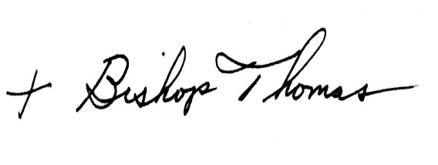Yours in Christ,

Rt. Rev. Bishop THOMAS (Joseph)
Auxiliary Bishop, Diocese of Oakland, Charleston, and the Mid-Atlantic

